CSC252 Programming in C++

How to submit your Assignment
After filling all the parts in this file, please follow the following steps.
- Add your name and ID to the first page.
- Save the file in the original format (Docx or Doc). Do NOT convert to other file formats e.g. PDF, ZIP, RAR, ….
- Rename the file as
YOUR First Name - YOUR Last Name- YOUR student ID- CSC252.docx

Example: John – Smith - 234566435 - CSC252.docx
- Upload the file and submit it (only using Blackboard)

Problem 1: Implement an Appointment Class (25 points)
Implement a base class Appointment and derived classes Day and Monthly. An appointment has a description (for example, “see the dentist”) and a date (month, day, year). It is recommended that the date be implemented as a class, but this is optional.

Write a pure virtual function occurs_on(int year, int month, int day) that checks whether the appointment occurs on that date. For a monthly appointment, only the day and year must match; for a day appointment, all three fields must match.

Fill in a vector of Appointment pointers with a mixture of appointments. Have the user enter a date and print out all appointments that happen on that date.

Write a program that tests each function and displays the results of their use.

Design, edit, run, test, and debug your program. Enter the completed C++ code here:
C++ code for the lab project:
<C++ code here>
#include <iostream>
#include <vector>
using namespace std;

// Base class
class Appointment
{
protected:
string description;
int year, month, day;

public:
Appointment(string desc, int y, int m, int d)
{
description = desc;
year = y;
month = m;
day = d;
}

virtual bool occurs_on(int y, int m, int d) = 0;

string getDescription() const
{
return description;
}

virtual ~Appointment() {}
};

// Day class
class Day : public Appointment
{
public:
Day(string desc, int y, int m, int d)
: Appointment(desc, y, m, d) {}

bool occurs_on(int y, int m, int d) override
{
return (y == year && m == month && d == day);
}
};

// Monthly class
class Monthly : public Appointment
{
public:
Monthly(string desc, int y, int m, int d)
: Appointment(desc, y, m, d) {}

bool occurs_on(int y, int m, int d) override
{
return (y == year && d == day); // follow assignment rule
}
};

int main()
{
vector<Appointment*> appts;

appts.push_back(new Day("Dentist", 2026, 4, 20));
appts.push_back(new Monthly("Pay bills", 2026, 4, 15));
appts.push_back(new Day("Meeting", 2026, 4, 20));
appts.push_back(new Monthly("Gym membership", 2026, 4, 10));

int y, m, d;
cout << "Enter date (year month day): ";
cin >> y >> m >> d;

cout << "\nAppointments on that date:\n";

for (auto a : appts)
{
if (a->occurs_on(y, m, d))
{
cout << a->getDescription() << endl;
}
}

// cleanup
for (auto a : appts)
delete a;

return 0;
}

Run the code, take a screenshot of the results, and insert the screenshot here:
Screenshot of the results:
<Screenshot here>
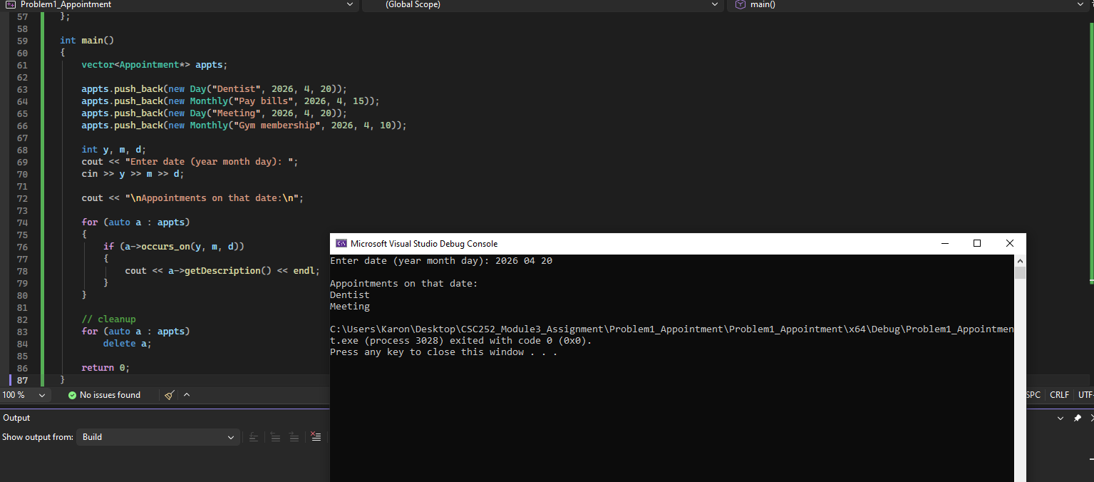

Problem 2: Implement the Person Class (25 points)
Write a program which defines a Person class. The Person class a name, a phone number, and an email address. Add a virtual toString() method that outputs a human readable description of the instance variables in the class.
Write a class called Student which subclasses Person and adds their year in college (freshman, etc.).
Write a class called Employee which subclasses Person and adds a salary.
Write another class called Faculty which subclasses Employee and adds a title.
Write another class called Staff that subclasses Employee and adds a role.
Override the toString() method in each subclass to output the additional instance variable information. Add the override keyword to each overridden method.
Create an array of pointers to Person. Add at least one instance each of Person, Student, Employee, Faculty, and Staff. Iterate over all Person instances in the vector and call the to_string() method.
For example, the output from a list of entities might be:
Person named Susan has phone number 800-555-1212 and can be reached at susan@quirkymail.com
Person named Jerry has phone number 123-456-7890 and can be reached at jerjer@nat.edu is in the sophomore year
Person named Larry has phone number 333-444-5555 and can be reached at larry@threestooges.org earns 123456.000000 annually
Person named Linda has phone number 987-654-3210 and can be reached at lindalou@whoknew.edu earns 150000.000000 annually is a/an adjunct professor
Person named Jane has phone number 567-123-6565 and can be reached at jane@whizkid.com earns 100000.000000 annually handles registration
Design, edit, run, test, and debug your program. Enter the completed C++ code here:
C++ code for the lab project:
<C++ code here>
#include <iostream>
#include <vector>
#include <string>
using namespace std;

class Person
{
protected:
string name;
string phone;
string email;

public:
Person(string n, string p, string e)
{
name = n;
phone = p;
email = e;
}

virtual string toString() const
{
return "Person named " + name +
" has phone number " + phone +
" and can be reached at " + email;
}

virtual ~Person() {}
};

class Student : public Person
{
private:
string year;

public:
Student(string n, string p, string e, string y)
: Person(n, p, e), year(y) {}

string toString() const override
{
return Person::toString() + " is in the " + year + " year";
}
};

class Employee : public Person
{
protected:
double salary;

public:
Employee(string n, string p, string e, double s)
: Person(n, p, e), salary(s) {}

string toString() const override
{
return Person::toString() +
" earns " + std::to_string(salary) + " annually";
}
};

class Faculty : public Employee
{
private:
string title;

public:
Faculty(string n, string p, string e, double s, string t)
: Employee(n, p, e, s), title(t) {}

string toString() const override
{
return Employee::toString() + " is a/an " + title;
}
};

class Staff : public Employee
{
private:
string role;

public:
Staff(string n, string p, string e, double s, string r)
: Employee(n, p, e, s), role(r) {}

string toString() const override
{
return Employee::toString() + " handles " + role;
}
};

int main()
{
vector<Person*> people;

people.push_back(new Person("Susan", "800-555-1212", "susan@quirkymail.com"));
people.push_back(new Student("Jerry", "123-456-7890", "jerjer@nat.edu", "sophomore"));
people.push_back(new Employee("Larry", "333-444-5555", "larry@threestooges.org", 123456));
people.push_back(new Faculty("Linda", "987-654-3210", "lindalou@whoknew.edu", 150000, "adjunct professor"));
people.push_back(new Staff("Jane", "567-123-6565", "jane@whizkid.com", 100000, "registration"));

cout << "People List:\n\n";

for (auto p : people)
{
cout << p->toString() << endl;
}

for (auto p : people)
delete p;

return 0;
}

Run the code, take a screenshot of the results, including the input and output files, and insert the screenshot here:
Screenshot of the results:
<Screenshot here>
